Current Market View – November 2025

Investment Markets
Global Markets
Global markets continued their positive trend, rising for most developed regions in November 2025, with Europe and the US outpacing Asia and Australia. Investors continue to discount the impact of inflation and interest rates on asset prices and continue to add to their "risk-on" positions. Equity investors welcomed the US interest rate cut in the last week of October amid signs of a slowing labour market and continued pressure on consumer prices, marking the second rate cut in 2025. This led to the resumption of the "buy the dip" mentality that had been prevalent in recent times.

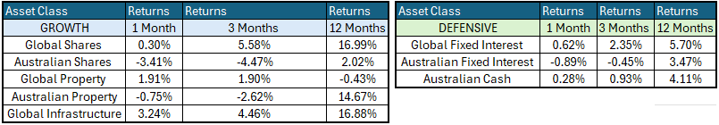

Whilst the Federal Reserve Bank (the Fed) remains focused on the inflationary impact of the tariffs, the economy is performing well, with limited inflationary impact from the introduction of US tariffs to date, which will likely lead to a cut in December.
Global Share Markets
Following an interest cut during the October FOMC meeting, US share markets are factoring in another 25-basis-point cut in the Federal Funds target cash rate for the next FOMC meeting, due to start on the 9th / 10th of December 2025. The Global Markets were mixed in November 2025, with the US and Europe outpacing Asia and Australia. Europe was the shining star in November, driven by resilient economic activity, easing inflation, and supportive signals from central banks, boosting investor confidence in value sectors.
Domestically, November was the weakest month of 2025 for the ASX since the Trump tariffs in February/March, at one stage down -5.5%, before rallying to finish "only" down -2.66%. Interest rate expectations were a key driver of markets in November, with a Melbourne Cup Day rate cut by the RBA evaporating amid higher inflation from electricity subsidies rolling off and stronger US employment data suggesting a December cut was less likely.
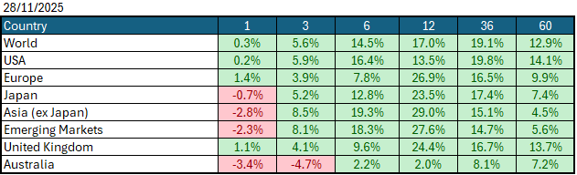
Data Source: AFM as of November 30 2025.

Global Bond Markets
Bond markets remain unconvinced by the tariff reprieve, believing that the outcome will ultimately lead to further inflation. The latest inflation data came in slightly softer than market expectations, with the market continuing to price in a US interest rate hike in December. Following the expected cut in December, the market is not pricing in any further cuts until the new Federal Reserve chair is announced and settled into the role.
Interest rate markets in the US eased over the month of November 2025, with the 10-year Government bonds increasing to 4.135%. UK 10-year Gilts were trading at 4.476% on October 30 2025.
Domestic Bond Markets
For Australia, the latest inflation prints for (year-on-year) October 2025 increased to 3.8% which was an increase from 3.2% in September 2025. The RBA board meeting held on 8th/December 9 2025 saw the target cash rate held steady at 3.60%, a continuation from the November meeting. The next RBA Monetary Policy meeting is due on the 2nd/3rd February 2026.
Investment Climate
In November 2025, US equities experienced heightened volatility as investors digested mixed economic signals and policy uncertainty. The month began with a 5% pullback, the first in six months, driven by concerns about the elevated AI-linked valuations and the belief that December could be the last month the FED cuts interest rates this cycle. In the background, the 43-day US government shutdown ended, but saw key economic data not published, adding to investor concerns. Despite these concerns, sentiment increased, supported by a resilient labour market and inflation prints that were all within market expectations.

Medium-term investors are encouraged by the anticipated gradual easing of interest rates; however, the unsettled nature of the share and bond markets clouds the short-term direction. The soft-landing expectations and economic recovery are still supported by the economic data, despite the recent volatility.
The medium-term view remains positive for returns, as US Fed Chair Jerome Powell appears to have shifted his stance to further easing of interest rates in the US by December 2025. At the 28th/29th October 2025 Meeting, the Fed eased interest rates by 0.25% to 4.00%, with the market anticipating another 0.25% cut at the 9th/10th December 2025 Meeting.
Long-term investors are optimistic about a recovery period ahead. Global central banks continue to indicate a resolve to get inflation under control; however, economic data is showing signs of stabilisation despite elevated inflation, and every indication is that future monetary policy easing is possible in 2025.
The following commentary is based on month-end closing prices as of November 30 2025:
Global share markets were mixed over November, with Europe and the United States outperforming Asian markets, as returns recovered despite the ongoing tariff situation and subsequent bouts of volatility following each tariff announcement. The AUD/USD strengthened from 0.6542 to 0.6550 (+0.13%)
The US Fed eased monetary policy to the target range for the federal funds rate of 3.75%-4.00% when it met on the 28th/29th October 2025. Investors are gaining more confidence that the economy is headed for a soft landing despite the intermittent bouts of volatility. The next Fed meeting is on the 9th / 10th December 2025.
The underlying short-term theme is "risk-on" for shares.
The situation in the Russia/Ukraine conflict remains unchanged; however, the latest conflict between Israel and Gaza (Hamas) has cooled.
Investor Focus
For Australia, investors focused on the following issues:
- Cost of living expenses and the impact on consumer spending.
- Commodity prices (post-China policy changes) and the impact on company profits.
- The level of interest rates and the delicate position of the RBA, given the global volatility in markets.
- US tariffs and the impact on Australia's exports (if any).
- Inflation (year-over-year) increased to 3.8% in November, with the next quarterly CPI being released on January 28, 2026.
- Government spending and the rising debt level.

Currency
The Australian Dollar closed slightly stronger, AUD/USD 0.6550 at the end of November 2025, up slightly from 0.6542. This was following the Fed cutting rates during the month and the RBA continuing to keep Australian rates on hold.
Currency forecasters see the AUD/USD range between:
0.5750 and 0.6750 cents in the medium term and most likely to trade within the:
0.5500 to 0.7500 range in the longer term.

Australian Economy
Australia's latest GDP data for the third quarter of 2025 revealed an annual growth rate of 2.1% which was up from 1.8% in the second quarter of 2025. Unemployment fell to 4.3% in October 2025. The year-over-year (Y-O-Y) inflation rate increased to 3.8% in October 2025, up from 3.4% in September 2025, which is now outside the Reserve Bank's targeted 2% to 3% inflation range.

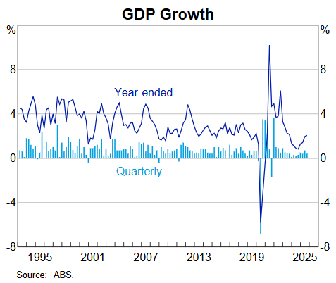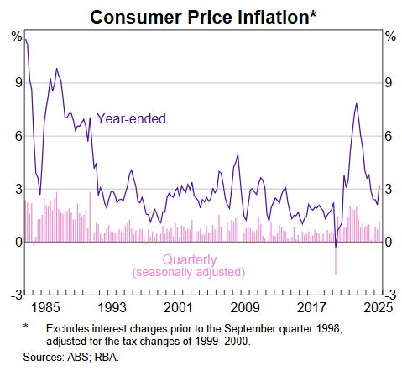

Current Market View

Domestic View
The overall investment view for shares is "risk-on" over the short term, "cautiously optimistic" over the medium term, and "long run" as interest rates are expected to continue trending down, depending on the implementation of tariffs and future anticipated easing of Monetary Policy by the RBA.
The market is expecting no interest rate cuts with maybe an interest rate hike on the 2nd/3rd of February 2026, due to a "hotter" inflation print in November that showed inflation is now outside the RBA's target range of 2-3%.

Global View
The global share market remains optimistic with ongoing support from the Fed, which is likely to cut interest rates at its December 2025 meeting. Inflation remains subdued as tariffs haven't impacted the economy fully. GDP remains strong in the US as AI infrastructure investment continues to boost spending across the country.

Where to From Here?
Tariffs have had a muted impact on our resource sector to date. Although the market initially overreacted on the downside, most of this has been unwound lately.
Overall, the bank reporting season was strong across all of the banks, with all banks demonstrating solid net interest margins, low non-performing loans and effective cost controls. All of the major banks increased dividends for shareholders, demonstrating to the market that they are performing well and see further options to grow earnings. The banks provide a good look through of the Australian economy, which looks to remain in a solid place despite higher interest rates.
The Middle East political unrest is a background factor that is not easily solved. Let us hope the situation will be contained and a solution that ceases further aggression and violence is forthcoming.
Markets are forward-looking, so it is likely they have taken a positive view of what lies ahead and started adding to positions ahead of the rest of the company reporting season.

This document is issued by Atlas Funds Management Pty Ltd. Atlas Funds Management Pty Ltd does not provide any general advice or personal advice regarding any potential investment in any financial products within the meaning of section 766B of the Corporations Act. No consideration has been made of any specific person's investment objectives, financial situation or needs. The provision of this presentation is not and should not be considered as a recommendation in relation to an investment in any entity or that an investment in any entity is a suitable investment for any specific person. Recipients should make their own enquiries and evaluations they consider appropriate to determine the suitability of any investment (including their investment objectives, financial situation, and particular needs) and should seek all necessary financial, legal, tax and investment advice. Atlas Funds Management Pty Ltd, it's directors and employees do not accept any liability for the results of any actions taken or not taken on the basis of information in this presentation, or for any negligent misstatements, errors or omissions. This presentation is not an advertisement and is not intended for public use or distribution. Past performance of a fund is no guarantee of its future performance.

